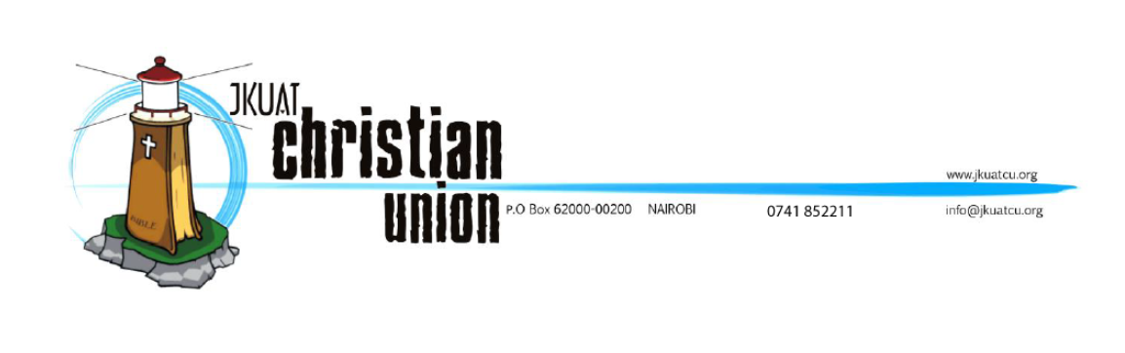

TITLE: PROPOSAL FOR THE FORMATION OF JKUATCU DEV TEAM

TO: EXECUTIVE COMMITTEE

BY: GEOFFREY KIMANI – MEDIA AND PUBLICITY SECRETARY 2017/2018

Contents

Problem Background 3

Problem Statement 5

Where we are 5

Where we desire/ought to be 11

What we should do to get there 12

Objectives 13

Specific Objectives: 13

Proposed Solution 13

Who is JKUATCU Dev Team? 14

JKUATCU Dev Team Structure 14

Director 14

Team Members 14

JKUATCU Dev Team Objective 14

JKUATCU Dev Team Duties and Responsibilities 14

Justification 15

References 16

# Problem Background

No man is an island, we live in a community and work well within a given group of people. This is true for our social lives, academic lives and spiritual lives as well, and this is why Paul encourages us not to forsake the fellowship of brethren. Hebrews 10:25.

It's needless to state, as it has been overstated in many writings and occasions, the necessity of working together. The common term given to using our effort to pull together, Harambe, has been a motto for this great land of Kenya. With many modifications to it with the popular telecommunication company saying, 'When we come together, great things happen.' (“Safaricom the Home of M-PESA,” n.d.) ⁠ It seems communism is here to stay longer than the new form of capitalism.

I have known about the JKUATCU Dev Team for about 1 year and 4 months, and it has been a wonderful experience working along all the members. However, the team must have existed way before this although not all the current members were aware of it. Upto this time, even being the media and publicity secretary for the while God has allowed me, I can't quite say objectively why the team exists or how it runs and if I can, it might not be necessarily in agreement with all the team members. Lemme pose the question to you, why does the JKUATCU Dev Team exist?

An ideal Dev Team has the following characteristics:

It composes of interdisciplinary members who include but not limited to:

* Project Sponsor
* Project Manager
* Subject/Domain Matter Experts (SME)
* Product Owner
* Technical Lead
* Software Developers
* Software Testers
* User Acceptance Testers

The roles and responsibilities of each of these member(s) may vary but they all work towards achieving a given goal;

Usability by International Standards Organization (ISO/DIS 9241) refers to “the extent to which a product can be used by **specified users** to achieve specified goals with effectiveness, efficiency and satisfaction in a specified context of use.” (Prof. Kimani, 2018) ⁠

The price is on the user and hence the focus should be on the price, the JKUATCU member. This is only possible if we have a team that can work together to earn the price.

Successful development projects take careful planning, a talented team and collaboration of a project’s team members, both internal and external (client representatives). (“main-base,” n.d.) ⁠

# Problem Statement

Allow me to break down this section in three portions:

## Where we are

As a union, we are not entirely offline, as we have various platforms and digital resources;

* Twitter Handle (JKUATCU)
* Facebook Account (JKUAT CHRISTIAN UNION)
* Telegram Bot (Underway)
* Bitbucket Account
* Website (www.jkuatcu.org)
* Portal (portal.jkuatcu.org)
* Windows Application
* Android Application (Jkuat Cu)

Quite a handful, the list may continue, we also have a Dev Team that has regular meetings. All may seem well but we, however, have some huge challenges we are encountering including but not limited to:

**Structure**: The Dev Team, unlike other ministries and committees, is not defined in the JKUATCU constitution and hence lacking a good structure to run its business smoothly over time. As you would notice the Dev Team;

1. Has no leader(s) defined by the constitution
2. Has no defined structure;
   1. leaders
   2. members
   3. qualifications
3. Its duties and responsibilities are not defined

With this it is left to run by mere chance making its consistency over years poorer, its structure and objectives, since it was formed, degrade over its lifetime.

This has also caused a ripple effect in other areas as highlighted below.

1. **Standards**: Owing to the fact that the structure is a problem, then the Dev Team has had difficulties with standards that drive the team forward. These standards include;

* Development Methodologies
* Programming Languages
* System Documentation
* System Maintenance
* System Reviews
* Training of members

This brings quite a mix up for the team since they have to come to agreement every time there is a new project to be worked on. This ripples down to the skill and services that the team has and can offer.

1. **Skill**: Since the structure and standards are an issue we then find that most of the members, I included, have insufficient skill. The reasons for this may be attributed to:

Some of our systems were developed quite a while and by few people, therefore, new members need to learn some of these languages and tools to be able to make relevant contributions.

Training sessions have been inadequate and not so well structured and thus leaving members not well equipped.

This then affects our services and maintenance of the systems we have.

1. **Services**: There has not been a great deal of improvement in our services for quite a while. Some of the services we offer through our systems are good but many other essential are left out. The available services are also not as smooth and efficient as a user would expect. Take the scenario of BS registration, log in to the portal is hectic for a majority of the members that Ed-IT team has to help out always, quite unfair to these members.
2. **Poor Documentation**: Owing to the lack of structure and the standards, then documentation of systems has become a real problem. Citing an example, we have two android applications, but none at all. This means that though one of our application is in the Google play store, we do not have the underlying code to it, and the application we have in bit-bucket is totally different from the one deployed. Take a look;



See the two icons, both with the same logo and name… interestingly, they are only similar in the outward appearance, let’s look at how each of them looks likes from the inside.

Then this is how each of them looks like:

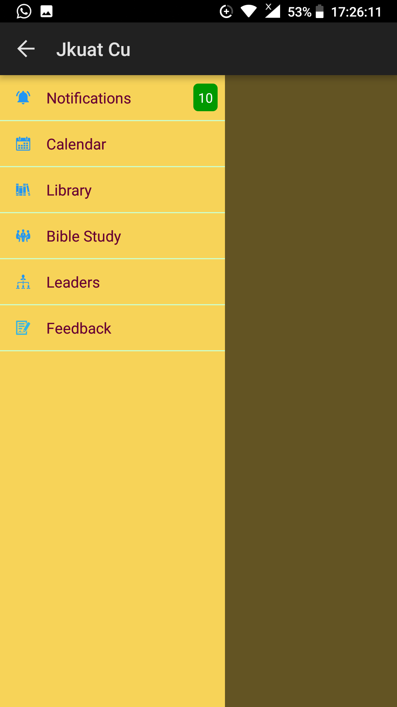Application one, from the bit-bucket account. It's incomplete though.

Application 2 from the play store.

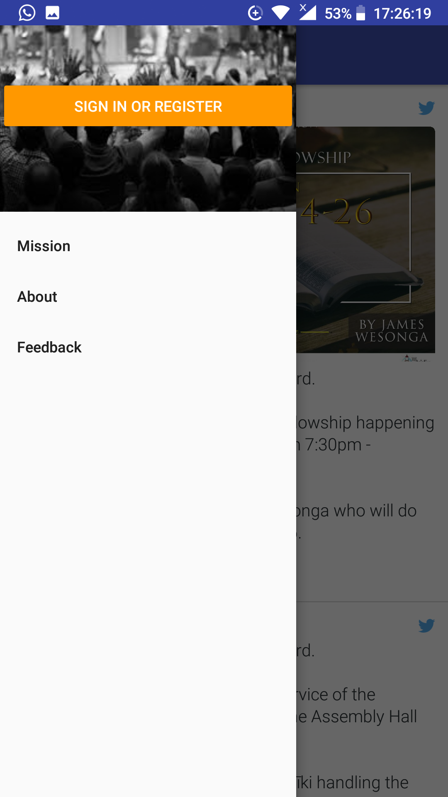

That's where we are at.

1. **Maintenance**: Since there is no structure to define when and how maintenance should be done, then some of the systems become outdated and no longer relevant to the user. Citing an example with the website, which is the blueprint of the union, it does not always contain up-to-date information. Check out if we have the list if interim exec in place or the semester activities for the interim period.

The team has been able to run despite these challenges.

The JKUATCU members have had to bear serious problems with some of our applications and services. The challenges include;

1. **Portal Log In**: This has been a nightmare to a great multitude of users of the portal and more especially during the BS registration period. The number of people asking for help in this area is frightening and that mere fact can make us question the number of people who are able to use other services in the portal comfortably.

1. **BS Registration**: Times have changed and so have regions under which the BS is conducted, though this has not been reflected in the portal. Some other areas that need to be updated are the courses offered. This reflects how rigid some of our systems have been.
2. **Portal Services**: We are in a digital era and we need to move with great speed to ensure that the old system of using physical forms has been eradicated. We are a few light years away from that, seeing that the portal does not provide some basic services like;

* Ministry Registration
* Prayer Group Registration
* Prayer Week Volunteers Registration

Among other kinds of registrations members may require to have.

1. **Outdated Information**: Our website has harbored old information that might not be relevant to members, with only a few sections being updated once in a while.

This can be attributed to many things but also the work being left to one individual, the website and database head in Ed-IT.

There is also little knowledge and publicity of our applications, both Android and Windows application.

The challenges from the members may be endless, but we now need to look at where we desire to be.

## Where we desire/ought to be

Being in the leading University in Technology, we ought to have better and outstanding systems than we currently do. Allow me to cite where I think we should be:

1. **Information**: Union members and non-members ought to have access to all the relevant and up-to-date information with great ease. The union's information dissemination channels should be made easy to use and have relevant information at all times that reflect the true state of the union.
2. **Services**: The systems that the union has should be greatly improved to ensure that they are serving the members. There should be constant reviews of the systems in contrast to the needs of the union members to ensure that services remain relevant. The services should also be made easy to use.
3. **Data Consumption**: The Christian Union is a large body and has many members. There is so much to learn about the Union through the data that is provided to us at the end of each semester. Am talking about the semester evaluation forms, the data consumption of the evaluation forms should be processed in different forms for various departments and leaders of the union to use. With this, leaders in the future can be able to make better decisions with the support of historical data.
4. **Constant Development and System Releases**: The union has great software needs, some of which cannot be fulfilled by the existing systems. There are many opportunities for improving the efficiency of work in the union by having different systems. Therefore, there is a need for a team that will be accessing some of these needs and developing solutions to suit the needs. Some of the areas I thought we would need systems include:

* A review of the software used to make financial statements (Existing)
* A message parser to aid the finance committee in settling accounts especially through the pay bill.
* An e-wallet service in the portal to help union members to save for events and activities that require huge amounts of money. e.g. Mission.
* An application to help in mapping out areas during mission activities. e.g. Help members to pin a point where they have been in door-to-door activities.
* A system to help in asset management in ministries and hence easing work on the finance committee and the auditing process.
* A system to predict financial trends of the union and hence making decision making easy.

The list may go on and on, but with all this, there is limited we can do unless we have a ...

1. **Dev Team**: There should be a team that will constantly review the union’s systems and accessing the needs for a new system. It should also work with the members to help them in using the systems as well as achieving **User Centered Development**, to ensure the user requirements of the system are met.

## What we should do to get there

It is easy, we need to formally define a team that will spearhead all this and set the objectives of the team in the work they will undertake.

# Objectives

The main objective of this proposal is to have a formally defined JKUATCU Dev Team which is acknowledged by the JKUATCU Constitution.

## Specific Objectives:

1. Improving JKUATCU systems.
2. Improving JKUATCU members experience in using the systems.
3. Providing more reliable and relevant services to JKUATCU members.
4. Improving efficiency in the running of the union by automating recurrent tasks.
5. Improving information dissemination to members and quality information used in decision making.

# Proposed Solution

To achieve the above-stated objectives, a team should be constituted and given mandate and resources to run. The team should, like any other ministries or committee, be under a representative in the executive committee and assume a structure similar to a committee or a ministry.

This is what we need to look into:

1. Defining who JKUATCU Dev Team is.
2. Defining a structure; leaders and composition for the JKUATCU Dev Team
3. Defining the objective of the JKUATCU Dev Team
4. Defining the responsibilities of the JKUATCU Dev Team

## Who is JKUATCU Dev Team?

This is an interdisciplinary team consisting of union members whose objective and responsibilities are as stated below.

## JKUATCU Dev Team Structure

The team should be linked to the Ed-IT Ministry through the website and database manager and to the executive committee through the media and publicity secretary.

### Director

1. Should be a member of the Christian Union
2. Shall be the head of the team.
3. Shall link the team to the Ed-IT ministry.
4. Should at least come from the computing field or have some background in computing.

I propose that the website and database manager be head of the team.

### Team Members

1. Should be members of the Christian Union
2. Should be team players
3. Should have computing background or deeply interested in technology.

## JKUATCU Dev Team Objective

To ensure the union systems, software and applications are up to date and providing relevant services to the union and its members.

## JKUATCU Dev Team Duties and Responsibilities

1. Identifying software needs in the union and making proposals to the Union to solve the needs.
2. Development of new systems, software or applications to suit a need(s) in the union.
3. Proper documentation of the union's systems, software and applications.
4. Ensuring constant review of the union's systems, software and applications.
5. Maintenance of the union's systems, software and applications.
6. Ensuring the union's systems, software and applications are up to date.

# Justification

With a Dev Team we can be able to:

* Achieve consistency in the team and thus improving on skill.
* Have a policy that defines the standards that tasks will need to conform to, promoting consistency and easy learning.
* Achieve better maintenance, documentation and reviews since the team's objectives are well defined.
* Achieve better services and a great improvement on the union's systems, software and applications. The team will be able to work more clearly and objectively now that their duties and responsibilities have been defined.
* The union's recurrent activities will be automated improving efficiency and thus energy can be focused elsewhere.
* Members will have access of up-to-date information with great ease.
* With time, information collected through evaluation forms will greatly aid in decision making and review of the union's progress.

# References

Kimani, S. (2018). Usability, User Centered Design, and Process Standards.

main-base. (n.d.).

Safaricom the Home of M-PESA. (n.d.), 10.